In this project, I modeled how a disease (which last 7 days) spreads through a population of 10,000 people whom each interact with 10 individuals every day. For a given infection rate, I determined “Herd Immunity”: probability of an individual getting infected as a function of the percent of the population vaccinated. For each infection rate, I plotted 35 data points of differing population vaccination percentage. At each infection rate, there is an observable “critical population vaccination percentage” where the percent of individuals uninfected in the population converges to 100%.

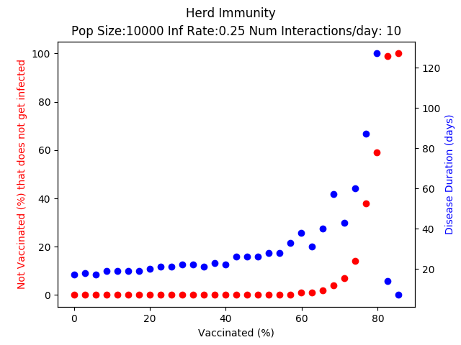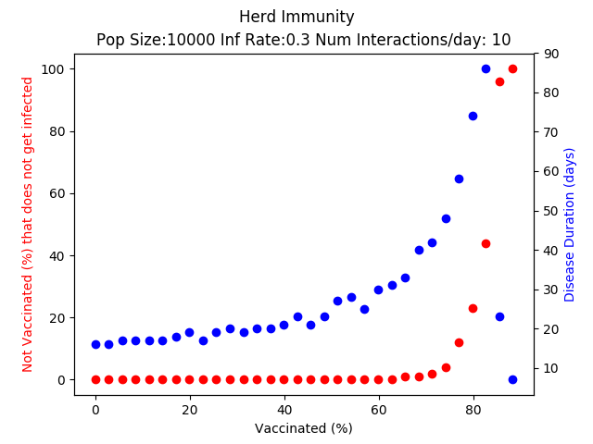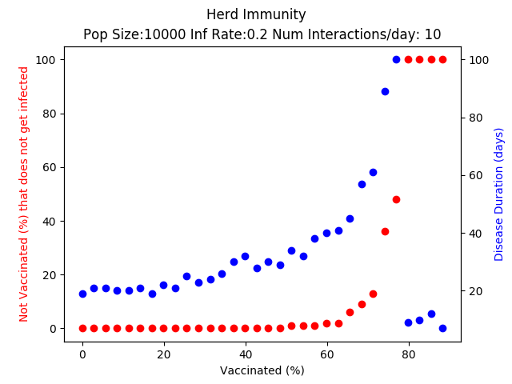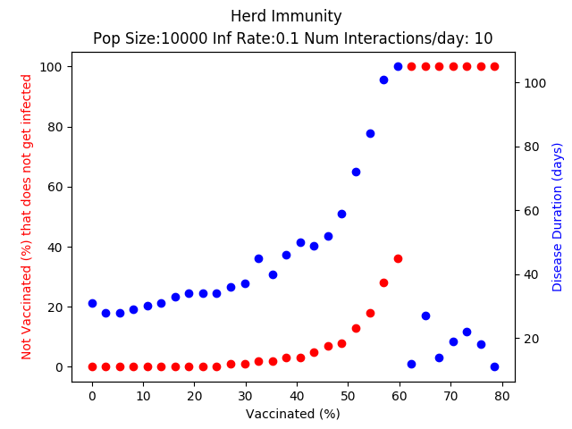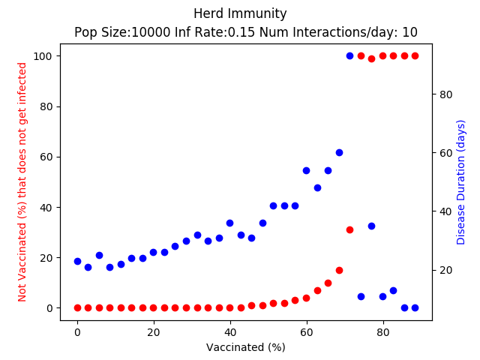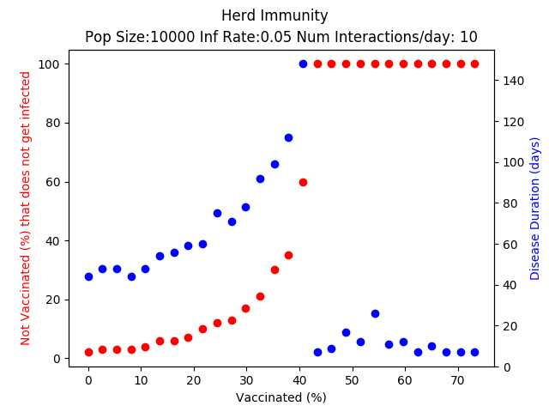Simulation models for infection rates from 5% to 60% are provided below:

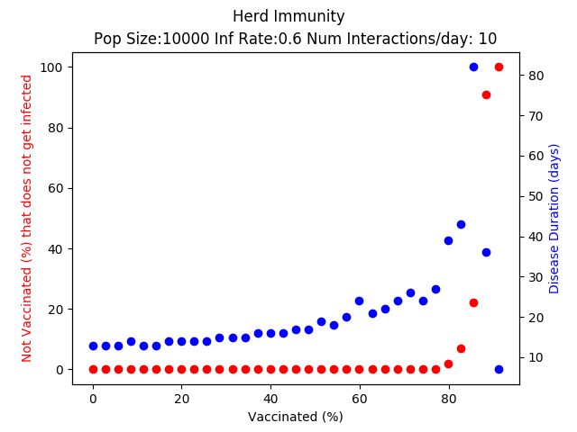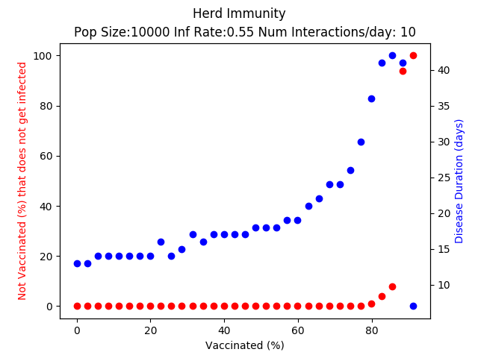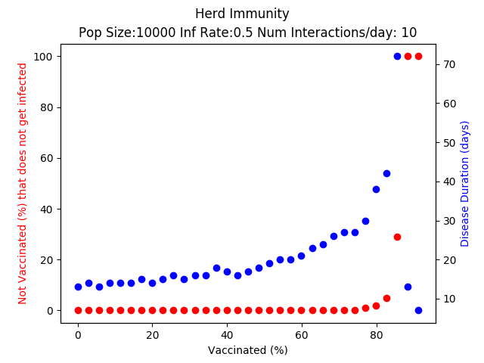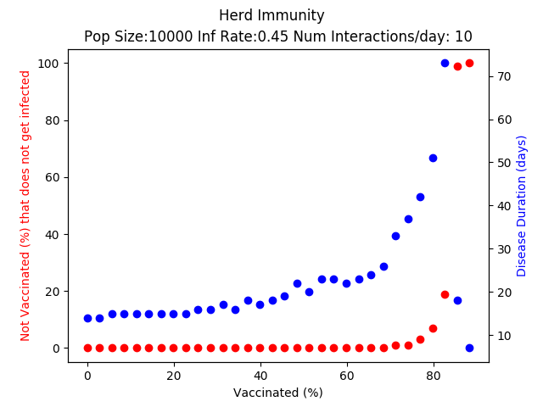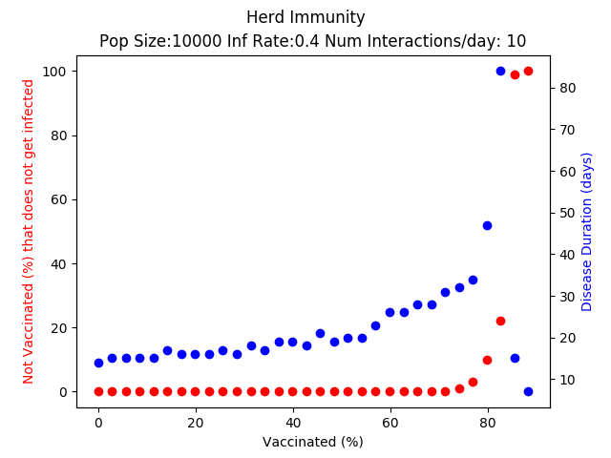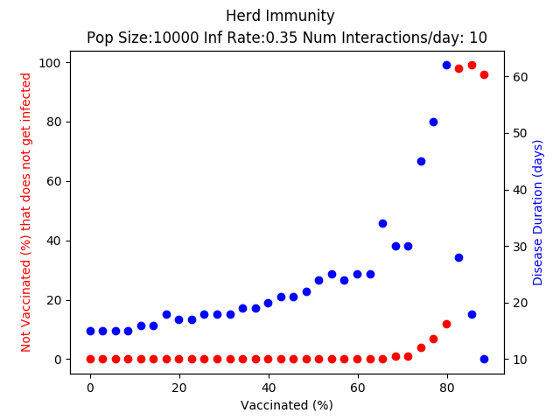

In conclusion, it is clear that as the infection rate increases the “critical vaccination population %” increases as well. Once the infection rate passes 40% the changes in the model become very subtle; herd immunity is not observed unless over 90-95% of the population is vaccinated. When the infection rate is at 5%, we observe herd immunity when only 40% of the population is vaccinated. The length (in days) of the disease models displayed interesting behavior. The number of days increased as a function of the number of people vaccinated in the population. However, once the critical population vaccination % is reached the time required for the disease to propagate significantly dropped. (Additional plots are provided in the directory)